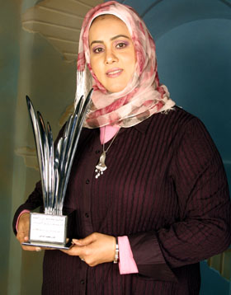
Bahrain
Huda Janahi
A True Ambassador of Entrepreneurship

Fifteen years ago, Huda Janahi started her business, Global Cargo and Traveller Services, with start-up capital of 1,000 Bahraini Dinars (around US$2,600 at today’s exchange rate). She ran the business single-handedly from an office in a small rented space in Muharraq, Bahrain's third largest city.
For the first year, all progress was blocked because her application for a commercial registration was rejected by the Ministry of Commerce. She was told that women could not receive a commercial registration to operate in the cargo industry. Undaunted, Janahi refused to accept no for an answer and she joined the UNIDO AICEI Enterprise Development & Investment Promotion program in Bahrain. In 2001, after graduating from the UNIDO entrepreneurship development programme, she applied again for registration and, with UNIDO’s support, her application was finally accepted.
Within a few years, Janahi built up her company into a huge successful enterprise and, in 2008, she signed a merger worth US$3m with the Kuwaiti cargo company, Global Logistic Company, which serves the whole Middle East region. Currently she owns 8 businesses in services, retail, media and manufacturing employing 85 staff and her net worth is estimated at $25 million USD.
Today, Janahi is an award-winning businesswoman, one of the most influential women in the Arab world according to Forbes magazine, and is hailed as a role model for budding female entrepreneurs across the Persian Gulf region.
Mrs. Janahi, has received numerous awards and recognitions; namely;
- In April 2005, under the patronage of HE Shaikh Mohammed Bin Rashid Al Maktoum, the Ruler of Dubai, she was awarded the Mohammad bin Rashid Award for Young Business Leaders for the ”Best Arab Start-up Business in the Arab World for the Year 2005”
- In February 2006, under the patronage of His Majesty King Abdullah II Bin Al Hussein of Jordan and Her Highness Princess Sabeeka bint Ibrahim Al Khalifa, President of the Bahrain Supreme Council for Women; she was awarded “Investor of the Year Award in the Category of Young Innovative Entrepreneur for the Year 2006” during the MENA Ministerial Meeting held at the Dead Sea, Jordan.
- In March 2008, she was awarded “The GCC Young Entrepreneur Award for the Year 2008” at the Women in Business Conference held in Oman.
- In May 2008 during the World Economic Forum held at Sharm El Sheikh, Egypt, the President of the United States, during his official address, recognized Mrs. Huda as an “inspiring example for the whole region”.
- In 2008, She was named as one of the 50 Most Powerful Businesswomen in the Arab World by Forbes Magazine.
- In July 2008, was named the First “Leader Entrepreneur Award” by HE Dr. Kandeh Yumkella, Director General of UNIDO during the UNIDO General Conference.
- In 2011 she was titled by UNIDO as an “Entrepreneurs Ambassador” for her active role in social entrepreneurship role through promoting women economic empowerment.
- In 2013, and as part of the G8 Summit held in UK she was awarded a “Certificate of Appreciation as a Woman of Achievement” by the G8 UK Presidency for the Deauville Partnership.
Mrs. Janahi, was invited by UNIOD as a speaker in the 5th Ministerial Conference of the Least Developed Countries in the Session “Converting commodities into products: the role of women in LDCs”; held in Lima, Peru from 30 November – 1 December 2013.
Most recently in May 2015; she was one of three Bahraini Women Entrepreneurs to receive the Indira Gandhi “Priyadarshani Award 2015"; for her contribution to women economic empowerment.
For UNIDO, the economic empowerment of women is key to building healthier, better educated, more peaceful and more prosperous societies, and the organization is working hard to ensure that women both help create, and benefit from, inclusive and sustainable industrial development.
Letting women participate more fully in economic life can yield enormous economic benefits but this is an area where the Middle East and North Africa (MENA) region as a whole lags behind. In the MENA region, the gap between men and women’s participation in the labour force over the past decade was almost triple the average gap in the emerging market and developing economies. If this gap had simply been double instead of triple, the gains for the entire region would have been enormous - almost US$1trn in output, amounting to annual gains of about 6 percent of GDP.
In the countries of the Gulf Cooperation Council, the regional intergovernmental union consisting of Bahrain, Kuwait, Oman, Qatar, Saudi Arabia and the United Arab Emirates, UNIDO is spearheading an array of initiatives to help economically empower women.
Back in 2001, Huda Janahi was one of the first women to benefit from the then recently launched Arab Regional Centre for Entrepreneurship and Investment Training (ARCEIT), established in Manama, the capital of Bahrain, as a South-South cooperation initiative of UNIDO, the Bahraini Government and India’s Inter-Regional Centre for Entrepreneurship and Investment Training. Since then, hundreds of other women have graduated from the ARCEIT Women's Entrepreneurship Development Programme, implemented in association with the Ministry of Industry, the Bahrain Development Bank and the Bahrain Businesswomen’s Society.
Since 2009, UNIDO’s Investment and Technology Promotion Office in Bahrain has been working with the national Supreme Council for Women to draft and implement the economic component of the Bahrain National Women’s Empowerment Strategy, which includes an Enterprise Development and Investment Promotion (EDIP) programme. The EDIP programme is a package approach that not only aims to develop the capacities of potential entrepreneurs and help them develop their own businesses, but also helps upgrade and expand existing enterprises.
In early 2011, ARCEIT, in cooperation with the Supreme Council for Women, launched a number of specialized entrepreneurship programmes based on the EDIP programme modality in various sectors, including media, fashion, photography, transport, translation, agribusiness and health and wellness.
ARCEIT has also established an Entrepreneurship Center at the Royal University for Women, the purpose-built university dedicated solely to educating women, located in Riffa, the second largest city in the Kingdom of Bahrain. The centre provides added value services to potential women entrepreneurs/students who aspire to start their own businesses. In the course of the development this centre, 20 professors at the Royal University for Women have been trained in the EDIP programme.
In 2013, ARCEIT was renamed the Arab International Centre for Entrepreneurship and Investment to reflect the centre’s role in spreading a culture of entrepreneurship and developing micro-enterprises in more than 44 countries. Speaking at the inauguration ceremony, Huda Janahi said transforming ARCEIT into an international centre confirmed Bahrain's position at the hub of entrepreneurship in the region. She said that establishing a company or turning a business concept into reality is now “very easy” in Bahrain, thanks to the spread of a culture of entrepreneurship, an abundance of government-provided facilities and the programmes offered by UNIDO.
In Abu Dhabi, capital of the United Arab Emirates, UNIDO has established a women’s economic empowerment centre, in cooperation with the Family Development Foundation. The centre will raise awareness of entrepreneurship and its potential contributions to economic development; strengthen national technical and institutional capacity to run and sustain an EDIP programme; enhance potential women entrepreneurs’ capacity to conceive, develop and implement income-generating activities; and enhance the performance and growth of existing women-owned enterprises.
UNIDO has also provided support to the MENA Businesswomen's Network, which leverages the collective energy of businesswomen's organizations throughout the region to shape the role of women in business and leadership positions. In January 2015, during the International Entrepreneurs Investment Forum in Bahrain, UNIDO officially inaugurated the Arab-African Businesswomen’s Council, in cooperation with the Arab Bank for Economic Development in Africa and the Arab Businesswomen’s Council.
To help women-led small enterprises transition from the informal to the formal sector, UNIDO has supported the establishment of a ‘Bank of Innovation’ with branches in Bahrain, Egypt, Jordan, Lebanon, Sierra Leone, Sudan, Syria and Yemen. The bank aims to provide micro- financing schemes without collateral to potential entrepreneurs to help them boost their businesses.
Thanks to these and other UNIDO initiatives, women of the Gulf, and beyond, who choose the challenging but potentially rewarding path of entrepreneurship, are better placed to succeed.
According to Janahi, “Entrepreneurs (should) reach out and share their ideas and problems with other established international entrepreneurs, as well as seek support from establishments such as UNIDO.”

Nawal Al-Sabbagh
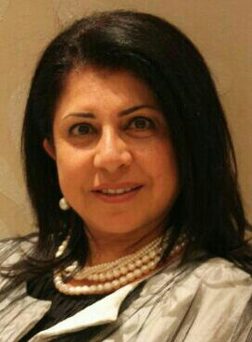
Bouquet of Triumph

Nawal Al-Sabbagh runs one of the best-known florist and chocolatier shops in Bahrain. Her clients include royalty and some of the most discerning and wealthy families who value her artistry and quality finish. Her unique story was not always roses though – or rather, it was a rose garden with its share of thorns. Through a failed partnership in an earlier business and the urgent need to provide for her children as a single mum grew her determination to rebuild her business and succeed once again.
“I come from a family where we were not entrepreneurial but we were very independent. From childhood I was taught to find ways to solve challenges and this stood me in good stead when I faced the issue of re-starting my business.”
Bahraini women have an in-built ability to surmount challenges, she says and organisations such as the Supreme Council for Women and UNIDO tap this strength and lend wings to their ambitions.
“We Bahraini women have a long history of independence and entrepreneurship but it needed to be re-shaped to fit the 21st century context. For this, UNIDO is an excellent mentor and a teacher for the new generation. It is a safety net for entrepreneurs and a guide for those of us who want to expand our established business.”
UNIDO has a clear step-by-step strategy to support women in Bahrain since it is involved in drafting women’s empowerment policies such as the 2009 drafting of the economic component of the Bahrain National Women Empowerment Strategy.
Nawal’s inspiring story of business reconstruction began when she found her earlier partnership falling apart just when she was also in the midst of a personal life crisis.
“Many of my former clients from the earlier flower business contacted me and asked me to handle their special event décor but I was unable to do so because I needed capital for flower and chocolate. I didn’t want to overload myself with loans although family and friends wanted to help. I am an artist and in all the turmoil, I had turned to painting to calm me. I sold these paintings to raise the capital and contacted my old suppliers. To my delight, they were happy to extend credit and help me to start again because they believed in my ability to succeed.”
Initially, Nawal worked from her home, supplying tastefully arranged flowers and gifts of top-quality chocolates to VIP clients. Her big break came when she went to BBK to negotiate a bank overdraft. It was Ramadan and the PR department was preparing to place an order of Eid sweets for VIP customers. Nawal persuaded them to use her artistic talent to create a custom-made Eid greeting and also her chocolate supplies.
“Entrepreneurs must always watch for opportunities. I was able to convince BBK of my reliability as a supplier and as a good SME client. I never used the overdraft but got a great client in BBK!”
The three secrets to business success, according to Nawal are to build trust in customers and suppliers because both are your partners in success; to offer quality at a reasonable price always and to always believe in oneself.
“UNIDO’s structured approach to enterprise creation and growth means that we have access to excellent counselling and global exposure. This makes the UNIDO Arab International Center for Entrepreneurship & Investment successful in its nurturing of women entrepreneurs and stimulating economic empowerment of women.”
Nawal is currently working with UNIDO to expand and enter the franchise business for her florist and chocolatier brand.
“You have to explore ways of reinventing your business and UNIDO has been very helpful in helping me to plan this next step into franchising. In this business, nothing smells sweeter than success!”

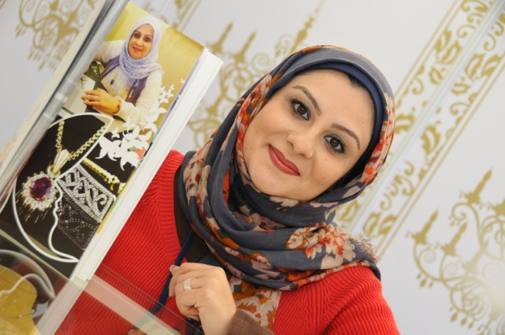
Khulood Abdulqader’s
Gem of a success story

The founder of Curve, a boutique jewellery atelier is Khulood Abdulqader, whose work combines the best of Bahrain’s pearling heritage and the narrative of contemporary Bahraini women’s empowerment through education and social support.
Khulood made the transition from government employee to entrepreneur in a stunning leap of professional empowerment, supported by her background in gem and jewellery science and by UNIDO. The former officer in Bahrain’s Ministry of Commerce & Industry's Gems and Pearl Testing Laboratory, was the first Bahraini woman to qualify at the Gemmological Institute of America (GIA).
“At first, I worked from home and showcased my creations at ladies' associations and bazaars attended by influential ladies. Soon orders started coming in and I decided to strike out on my own. I was content with the fact that my reputation was growing and I was making about $ 5,000 to $8,000 USD a month in profits. But UNIDO raised the bar on my ambitions. I learnt to professionally channel my talent and gained valuable technical knowledge on how to run a business.”
Today, Curve Jewelry has an annual turnover of $1 million USD a year and a net worth of $3 million USD.
"When I started, I had the technical skills from my work at the Ministry's gem lab and my study at the GIA. I had the flair and creativity that got me clients. But it was UNIDO that taught me to prioritise my growth and business development. UNIDO supported me and helped me to leverage my skills to get bigger loans for my business expansion, for example."
She says the Bahrain Business Model which UNIDO has created empowers entrepreneurs by teaching them to think big.
"My establishing my business was a first step. It was through UNIDO that I got the exposure in regional exhibitions to see and understand current industry trends and promote my own creative vision. I am now working with the UNIDO team transform my business into a franchise concept in the region. It is a big step in an industry that is dominated by brands with centuries of fashion history. I could not do it without the confidence boost that UNIDO gives me.
And her advice to potential women entrepreneurs is "Take full advantage of the opportunities that UNIDO places before you. It is your doorway to new success and growth."

Ahmed Al Sawafiri, Start-up Bahrain

Ahmed Al Sawafiri is a young entrepreneur who attended the EDIP in Bahrain in 2002. He realized that there was a need for a community-driven, independent platform connecting entrepreneurs and the entities seeking to empower them. In accordance with this, he created Bahrain’s first and only community powered, digital magazine on startups and entrepreneurship. The business conception began in 2013 with Ahmed and his brother Mazin Sawafiri, as they started with an minimal investment size.

“We’re a team of Bahraini designers, writers, photographers, and entrepreneurs, who have contributed the best to our industry, locally and abroad. We aim to challenge the current expectations and aim higher. Startup Bahrain is Bahrain’s first and only award- winning and independent digital publication for startups and entrepreneurship. Thousands of readers rely on its interactive, educational, and inspirational content to help start and grow their businesses.”

He is hoping to align Startup Bahrain with the goals driving Bahrain’s Economic Vision 2030: encouraging dialogue and critical thinking, sharing knowledge, inspiring success, and promoting healthy risk-taking and competition. With 14 great issues, downloaded from over 90 countries, Start-up Bahrain is aiming for 10,000 loyal readers by the end of the year.

Abdulla Al Shaowi, FIT Gym & Spa

Abdulla Al Shaowi is a young entrepreneur who attended the EDIP in Bahrain in 2010. He had a vision of a Bahraini Gym with professional trainers and a full feature of services for all Bahrainis youths who want an effective fitness plan and pursue a healthy lifestyle. On October 17th 2011, he fulfilled his aspiration and established “Fit Gym and Spa” in the Riviera Palace in Sehla, Bahrain.

The facilities included a gym, swimming pool, jacuzzi & steam room along with adequate changing rooms and lockers plus a coffee shop with nutritional products. In the beginning, Abdulla invested BD 65,000 and had a workforce of 4 employees. In 2012, he expanded the space of the gym and added new machinery and equipment. Today, his business is turning a profit of 50,000 BD with a total workforce of 8 employees. In the future “Fit Gym” is going to include a ladies-only section, double the area of the free weights training, install a Sauna and add a kitchen with seating area for all its members.

Doa'a Essa Abdul Wahab, Salad Boutique
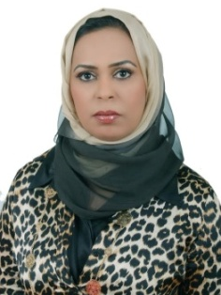
Doa’a Essa Abdul Wahab attended the EDIP in Bahrain in 2009 and she had a vision of a restaurant that was healthy but also ‘a piece of art’, that is boundless and universal. In 2009, she started Salad Boutique; a unique bistro created by three Kuwaiti food-loving entrepreneurs, known as a place not only for its difference, but also for its creative approach to food.

Salad Boutique is a one of a kind destination, valued for its gourmet salads, and contemporary lounge setting and indulging the senses in a menu, which consists of whatever salad one’s heart desires, ranging from green, chicken, steak , pasta and even fruit salads. The place is also known for its decadent decor, ipad menus and funky music but for its creative approach to food and service. The first outlet was in Kuwait and other outlet was set to open in Jeddah and Bahrain in 2011. The initial investment was $350,000 and Doa’a started with a staff of 15 employees, and by 2012, the rate of investment return is 8% and there are currently 21 employees plus a new delivery service for the restaurant. In the future, there are plans to add catering, event planning, corporate rates and as always Doa’a wants to take Salad Boutique beyond the borders of Kuwait and into the global arena by planning to open a new Salad Boutique in Qatar by 2013.
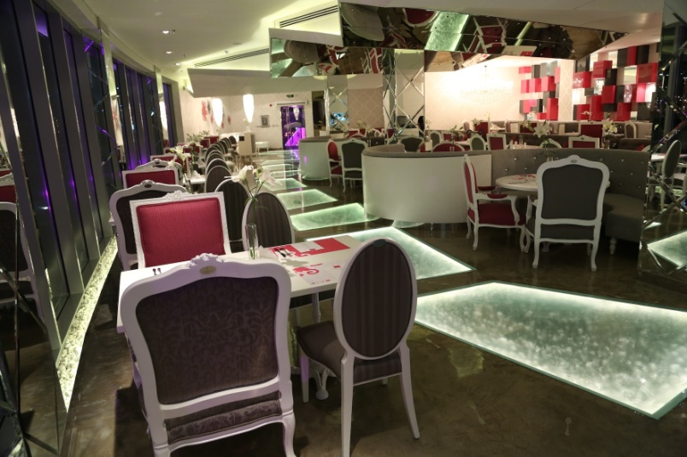

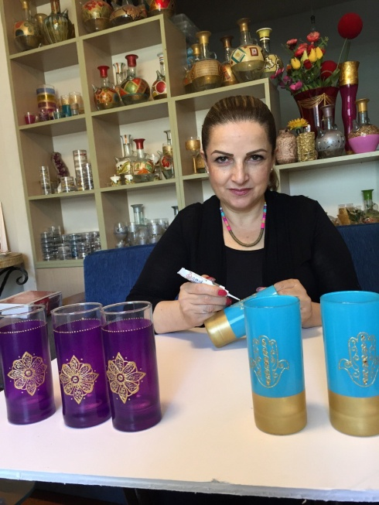
Lebanon (2015)
Samar Itani, Lebanon
Playing with the Sands of Success

Samar Itani’s idea was simple and beautiful: she collected sand from the seashore and used it to decorate creative art objects that she had made or she tinted it in various colours and bottled it in eye-catching layers that would decorate a home interior.

At first, this artistic Lebanese lady worked on her own from home and her business was a small home-based hobby where she made money by selling her creations to family and friends. Today, “Samar Handicrafts” has a flourishing art business that yields an income of $140,000 annually and an atelier with 28 ladies helping her to finish the monthly demands she has to deliver. She is teaching in Fabriano College, and she is a partner in an art college-gallery. She also runs a training centre through which she mentors other women entrepreneurs and passes on the lessons she learnt in the UNIDO-EDIP programme.

“ I went into business on my own in order to support my family, through having additional income, before becoming the only breadwinner for 3 teenage boys,” she recalls, “I started from home creating artistic projects, till I felt the need to learn new hard skills to reshape my talent. So I went to an art school and studied art and design.

I started to go deeper into my business, and I started to teach art as well. But it was at UNIDO’s EDIP Lebanon program that I attended through the Hariri NGO that I realized how much goes into a successful business mix. We got soft skills training and learnt about cost analysis, pricing, marketing and more. Counseling sessions followed to bring things together, to complete the picture of a business that turned into a career.”

With the UNIDO-EDIP program, Samar learnt to update the way she ran her business and streamline it for success, expansion and profitability.

The UNIDO EDIP program helped Samar to re-brand her business and helped her to think big and turn her business into a smart business. As a first step, her mentors in the program helped her to assess the market and come up with a redefined product line that met market needs. The program helped her to gain the hard skills support by giving an opportunity to needy housewives to work with her and get paid depending on their productivity and at the same time meeting her customer commitments. The UNIDO-EDIP support enabled Samar to expand from Lebanon to GCC, especially after she participated in Bahrain in the UNIDO women entrepreneurs’ forum.
Being a member in the Artisan League, Samar helped to establish the EDIP Lebanon Entrepreneurs’ Market where the League set up a Permanent Exhibition with the support of the Ministry of Industry.

In conclusion, Samar said, “Lebanese women entrepreneurs are good fighters, they are struggling to survive in a masculine society and a critical country. I advise the entrepreneurs to focus on their businesses, and UNIDO entrepreneurs to benefit from this opportunity that guides them to think, start and grow their own dream.”
Naziha El Koush, Lebanon
Upcycling to Entrepreneurial Excellence
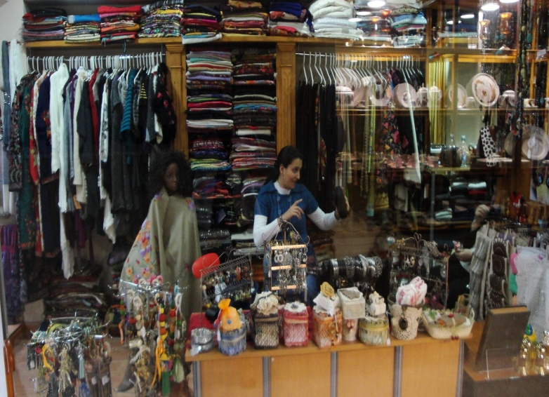
Nigerian Naziha El Koush’s journey to entrepreneurial success in faraway Lebanon was paved with non-useful recyclable goods. The skilful artist transformed these into objects of art for interiors and won herself a reputation for craftsmanship that led to a shop in Hamra under the name Tasmim.
This giant leap came about when Naziha combined her innate artistic talent with the business skills that she learnt through UNIDO’s EDIP program – drawing up a business plan, doing a feasibility study and making a business budget. At the legal level, UNIDO helped Naziha to establish her business officially and taught her to market her creations. Through UNIDO, Naziha found access to exhibitions and events where she could showcase her creations and build her brand.
“I developed my talent by studying interior design and took recycling as a theme for my project. I transformed all non-useful things to art and décor objects or to utility items.
Through the EDIP program, we started to know more about how to start our own business the right way, how to manage our project, how to market our products, and lots of other important things that we continued to learn about through counselling sessions. Counselling is a continuous support and a follow up for all entrepreneurs to solve business problems and find solutions,” she said, “UNIDO EDIP Lebanon helped us to develop our business differently, i.e. from a professional perspective, and is always there when help or support is needed.”
Naziha’s husband Walid is also a UNIDO beneficiary entrepreneur and upon his return from Nigeria to Lebanon, the couple decided to pool their skills and business learning to expand the family project. Today, they have roped in their children and Naziha’s mother and sister into a profitable line of customized art stationary where one can customize your gift of stationary depending on what you like or what the person receiving the gift likes.
This second project is in Bchamoun and reflects Naziha’s efforts to expand in Lebanon.
A true indicator of Naziha’s success is the fact that her income has risen from a mere US$100 to $2000 a month and currently employs 6 women staff.
“Lebanese women entrepreneurs are very strong, and may be present in the market even from their home. They are fighting all kinds of competition they face from foreign labor to save their existence in the local market. But entrepreneurship is a joyful and challenging voyage especially for women. I started out as an entrepreneur to fit my ambition to my time – I was a mother of three children with free time in the mornings only. Today, thanks to UNIDO, I have graduated from running a small home business to running a successful family business that nurtures my creativity and brings in good income.”
She added, “I advise entrepreneurs to take the risk - UNIDO entrepreneurs are very lucky, they should grab each and every opportunity to benefit from, and to follow step by step the action plan they put in place with the help of the counselor.”

Lebanon (2013)

Yakout Faddoul, Mama’s Sweets

Yakout Faddoul was a housewife with a love for cooking, especially sweets for various special occasions. Through EDIP Lebanon, she acquired the skills to transform her passion into a micro business from home which developed into a small business in Ain Al Remaneh. She initially invested 300,000 L.L into the business, and with one employee, she began selling two types of traditional sweets; Mamoul at Easter and Buche at Christmas.

As the demand grew and she slowly began to earn profit, she began to package her items and distribute to local minimarkets and schools within the region. At first she was earning 600,000 L.L per season (10 months), as of 2013 her turnover is 8,000,000 L.L per season. She has also taken more part-time staff consisting of other house-wives from the neighborhood and expanded her products to provide a range of traditional sweets, English and French sweets, pastries and savory snacks.

In the future, she plans to expand her market. Yakout will be targeting other regions in Lebanon and through her daughter and continued market research; she is planning to distribute her products to Qatar in 2014.

Lebanon (2012)
Alexandre Nehme, Herbatica

Alexandre Nehme is a Lebanese entrepreneur with an educational background in Herbs and Aromatherapy from the Ecole Lyonnaise Plantes Médicinales in France. He has been supported by the EDIP program through which he was assisted in developing a bankable business plan thus leading to a loan worth 200,000 USD through Kafalat. In 2011 he established a full production facility for herbal cosmetics; Herbatica.
Mr. Nehme, was nominated and supported by UNIDO ITPO Bahrain and the EDIP Center in Beirut to take part in the 7th Arab Business Plan Competition for Arab Innovators in 2011 where he won second place from over 6,000 Arab innovators who applied. His business was later classified among the top 20 most innovative businesses as part of the World Business Plan Competition held in UC Berkley in cooperation with Intel Corporation.
Mr. Nehme started the business in 2011 with a total investment of about 640,800 USD and a total of 4 employees in Lebanon. Currently Herbatica has a net worth of $2 million USD and employs 16 staff and selling upto 28 purely herbal products globally. In the future, the business is planning to continue to attend worldwide exhibitions like the “Bahrain International Garden Show” as well as enter into new markets and start bringing out more edible and drinkable health products
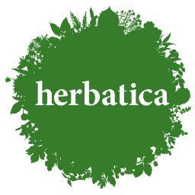
Sudan (2015)
Haifaa Mohammed Hassan Eltayeb, Sudan
Teaching the rules of success

From the time she was a young schoolgirl, Haifaa Mohammed Hassan Eltayeb remembers admiring her teachers at the Italian convent school that she attended in Sudan. She recalls that when she came home from school, she would line up her text books as imaginary students and imitate her teachers.

“As far back as I remember I wanted to become a teacher and I qualified accordingly - I graduated from University of Khartoum, Faculty of Arts, did my MA in English Language ,CELTA from University of Cambridge, Mini master in Business, Knowledge Management and Lean Six Sigma. I started teaching and gained valuable experience in teaching the British Curriculum. I worked at many schools in Sudan such as Cambridge ,ABC Language School,Alruya Bilingual School as well as abroad in KSA-Riyadh at AL Kanar- Alolyia teaching IGCSE. I was appreciated by the school management everywhere for my abilities as a good teacher and praised as a valuable asset to the schools – I was even promoted to be an academic manager at Cambridge Training Center and Cambridge International School. But always in my head, I nursed the ambition to have my own business, be my own leader and accept the risk. My problem was that I did not know how to start!

Coincidentally, in December 2011, there was an announcement in the newspaper about the UNIDO Enterprise Development & Investment Promotion Program (EDIP). My husband and I attended this fruitful program, we were taught to translate our dreams and ideas into working reality. The course leaders taught us how to make our plans, prepare the feasibility study which can guide us and how to nurture our entrepreneurial spirit. This is how we thought of starting a school in the Jubara Area of Sudan because there is no British School there. I was the pioneer in that.

To start with, I had just the equivalent of US$ 1100 to invest and to this we added our savings and insurance and rented the house for the school. We bought the assets and equipment in installments. I started my school as a kindergarten in June 2014 with 60 students. In 2015-’16, I plan to open the primary section.

In my opinion if this UNIDO program wasn't there I wouldn't have found the motivation to become an entrepreneur. The challenges that I face - the inflation ,the teachers training, having my own buses ,marketing – I was able to find solutions and the courage to go ahead because of the UNIDO program.

In the future, we would like to expand our school into a VIP Academy. I am currently working on the training center that provides training for language, soft skills and entrepreneur courses in home packages for individuals and corporates based on the requirement. I conclude that UNIDO must continue its valuable work of empowering women entrepreneurs in Sudan. The need of the hour is awareness of our strengths, the proper way to run a business – I humbly suggest that UNIDO-ITPO should stretch its resources by twinning with universities and take the message of effective entrepreneurship to youth also. I always tell Sudanese youth to stay and make something in their country and not to immigrate; it is programs such as the UNIDO-ITPO EDIP that will help us to empower our women and youth and give them the strength and knowledge to share in the progress of our country.

Ayat Abdulaziz, Sudan
Harvesting success as an agropreneur

Sudan has a pool of bold and fearless women who have made a mark for themselves with their strength, innovation, creativity and success. Their relentless zeal, incessant thirst for success and willingness to walk the extra mile have broken all myths about their inborn limitations that were supposed to be major roadblocks on their success expressways. These women entrepreneurs inspire other women with dreams of founding startups. However, there are still many challenges that female Sudanese business owners have to face because of their gender. In addition, they have to wear many hats, from businesswoman to family woman and balance raising families with running their businesses.
It is here that the UNIDO’s EDIP program comes into its own because it sustains the aspirations of these women and shows them new ways to reach their business goal and grow their business. One such person is young Ayat Abdulaziz. At about 27 year old, she completed her University studies in the area of Forestry and Range Management. She decided to become an entrepreneur by taking a loan from Sudanese Micro finance Institution and going into the fodder business. She began by renting 10 feddens of farmland and began alfalfa farming. She made just enough to get by and support her family, but her business required grueling hours.
“I had to be at the farm by 5:00am and would close at 11:00 pm. It was hectic and I had no time whatsoever with my family,” Ayat says.
Ayat began looking for ways to make extra money and decided to try sheep farming. But she was disappointed when her first offspring performed poorly. At this low point, she attended the Entrepreneurship Development and Investment Promotion Program with other members of her youth group. Her inspiration came after completing 30 days capacity building program which is the first step in the EDIP. It served as a turning point and an eye opener to her.
As a first step to success, Ayat put together a proper business plan to invest in mixed farming benefiting from the continuous counseling services provided by the EDIP program. Next, she moved from working in the informal economy to the formal sector by officially registering her business and acquiring an official registration certificate. These steps helped her to expand her cultivated area from 10 feddans to 40 feddans. Now, alongside her mixed farming plan, Ayat began to explore several ancillary businesses: she started to formulate, produce and sell organic fertilizer to farmers in her village; she provided them with technical advice; she expanded her animal production by increasing sheep herd from 18 to 36 animals; she also established another business line in the areas of nursery and landscaping .
As a mark of recognition, Ayat was selected by the Omdurman National Bank as a leader in a youth employment project targeting youth in the agricultural sector. It focuses on making agriculture business attractive and her role is to teach other youth in her area agriculture production technologies, improved compost preparation, sustainable insect and pest management using local botanicals.
Ayat believes that Sudanese women are as good as men when it comes to hard work, intelligence and leadership traits.
“The new generation of Sudanese women have overcome all negative notions and have proved themselves beyond doubt in all spheres of life including the most intricate and cumbersome world of entrepreneurship.” she says, “I am trying to encourage Sudanese women to get into agribusiness since it is an especially good venture. I started with a loan equivalent to about US$ 1000 and today my annual net income is about $25,000. I believe that UNIDO E.D.I.P. was a blessing that turned my business, my life and perspective around. It gave me clarity and helped me to reorganize my business on more profitable lines and also supported me in maximizing my potential as a farmer by introducing me to new lines of farming activity.”

Manal Mustafa Hassan Ali, Sudan
The Sweet Taste of Success

Manal Mustafa Hassan Ali is a housewife and mother of five children. Although she had a BSc in accounting from Sudan University for Sciences and Technology, Manal’s first love was making sweets and cookies. After marriage, she started making sweets and cookies for friends and family to keep her busy while looking for a job.
Support from some friends and family and an abundance of positive responses to her sweets and cookies made her decide to take the entrepreneurial leap and follow her heart to the world of sweets and pastries. Her humble business beginnings in her kitchen built her reputation for excellence and unique taste. She joint Entrepreneurship Development and Investment Promotion Program (EDIP) which was conducted in Khartoum in November 2005. The program helped her to put together a professional business plan and this was a stepping stone for her to benefit from the UNIDO Technology Tie-up program. She travelled to China, India and Bahrain to see how the sweets and biscuit/cookie business was run and returned with a much wider vision for her business.
Upon her return, Manal expanded her original business and today produces a wide variety of delectable pastries, daily fresh pizza, cakes, tarts and other delicacies. Since her focus has always been the best quality and the use of the highest quality of raw ingredients with no added preservatives and at the best possible price, she has a well-deserved reputation and a fine brand name in Khartoum city. From cooking up batches of sweets and cookies in her kitchen with her maid’s help, Manal today employs 32 women workers, has a fully equipped production system, two vans for transporting her products and cope with demand.
“When I started, my biggest challenge was marketing my products and funding my business. To get some money to fund my business I received a sum of US$ 1000 as seed capital - a gift from my husband. Since I do not like the idea of borrowing money from financial institutions, I worked within a tight budget. As for marketing, I was not very confident when I first started my business but with the help of EDIP that I attended, I was able to overcome the fear of marketing my products.” Manal says.
Today her business capital is US$ 1 million and her annual net income equals US$ 120,000.
This successful businesswoman says, “Attending EDIP and ask for business advice from UNIDO experts. Being positive, believing in oneself and being happy is very important to function as an individual and a women entrepreneur.”

