The Enterprise Development & Investment Promotion Program (EDIP)

The EDIP is a package approach aimed at developing the capacities of potential entrepreneurs in order to boost their capabilities and assist them in developing their own private businesses. The process is based on an approach that deals with building entrepreneurial capabilities in addition to enterprise planning, implementation and management.

The EDIP is multifaceted in the sense that it need not only assist in developing start-up entrepreneurs (Enterprise Creation Program) but rather represents a major mechanism for upgrading and expanding existing enterprises (Enterprise Growth Program). Through the provision of value added services, tools and programs to potential entrepreneurs. Moreover; it facilitates and promotes domestic investment which undoubtedly leads to the attraction of foreign direct investments mainly through the linkage with the UNIDO ITPO Network, thus leading to job creation and a more diversified economy.

Further to the above the EDIP has evolved into a practical well-structured Incubation System in addition to that it encompasses non-financial and financial services.

The EDIP consists for five steps: (Please note that detailed EDIP steps are in Annex 1)
- Pre-Incubation
- Preparation & Empowerment
- Business Counseling & Technology Tie-up leading to full-fledged joint ventures
- Financial linkages
- Incubation (In-Wall and Virtual)
- Post Incubation and Growth programs

A. Enterprise Creation Program

The Entrepreneurship Development process is based on a theory or belief, well -grounded on historical experience that entrepreneurs are not only born but can also be trained and developed. It is of course recognized that all individuals do not possess entrepreneurial traits-desire to do something new and unconventional in a specific context, to be on one's own by starting one's own business and thus to climb the social ladder-" but some do have such traits irrespective of socio-economic class to which they belong.
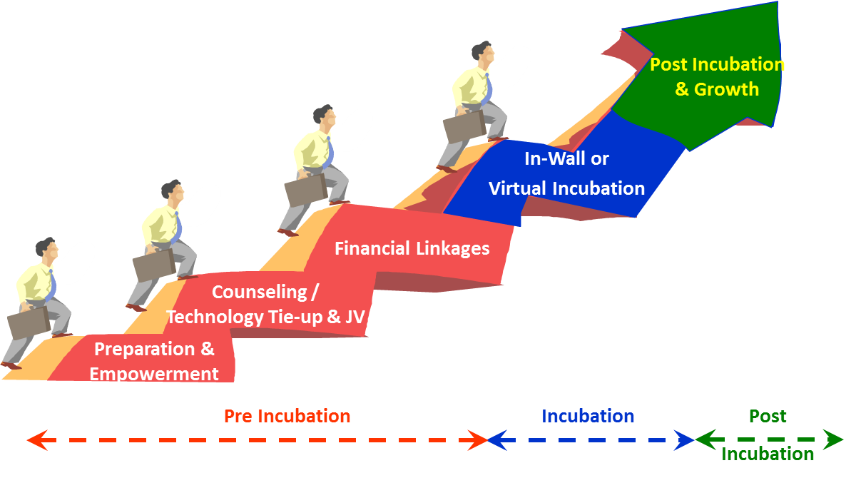

Enterprise Development & Investment Promotion Program Modality

Hence, the program designed is into four steps and is aimed at helping potential entrepreneurs/investors translate their ideas into commercial ventures in the manufacturing and service sectors.

Pre - Incubation

1st STEP – Preparation & Empowerment
With the ultimate objective of assisting the potential entrepreneurs/investors to set up their own enterprises, the business skills development has been designed to cover the following:

- Setting up an enterprise: Rules, procedures and formalities, whom to contact for what, nature and extent of assistance available from various institutions
- Business Opportunity Identification: How to identify business opportunities, how to screen them, how to firm up a business idea for further exploration.
- Market Assessment: How to assess the market potential, guidance in carrying out field work for market assessment for the proposed product/service
- Entrepreneurial Competencies
- Business Plan: Skills in preparing a Business Plan and assistance in finalizing it
- Essentials of managing an enterprise
- Inputs on how to implement a project/enterprise

The organization of a business plan competition has been added to step one which represents a major component for assessing the effectiveness of the program and whether the potential entrepreneurs/investors were able to acquire the needed skills and competencies.

2nd STEP - Counseling & Technology Tie-up possibly leading to a full-fledged Joint Venture

Subsequent to the preparation & empowerment step, a vigorous follow-up mechanism to provide business counseling with the ultimate objective of facilitating project implementation. Developed entrepreneurs/investors are helped in finalizing their business ideas and in obtaining necessary information and preparing their business plans/investment profiles as per UNIDO methodology. A very crucial component is provided to entrepreneurs, enabling them sourcing technology tie-ups which could also lead to the development of full-fledged partnerships; which is carried out through the UNIDO-ITPO/IPU Network (Annex 2). In addition to that administrative support on legal and licensing issues are facilitated through the respective government entities.

It may be noted that the nature and extent of business counseling services depend on the needs of respective entrepreneurs. The counseling & technology tie-up step is a lengthy relationship between the counselor and the entrepreneur/investor. It may generally include the following activities:

- Business opportunity identification, analysis and finalization
- Market research – Collection, analysis and compilation of relevant data
- Identification and sourcing information on appropriate technology, machinery/equipment, and raw materials etc.
- Facilitating technology tie ups which could lead to the establishment of joint venture collaborations (annex 2)
- Business plan preparation
- Completing legal documentation and seeking necessary registrations/licenses/clearances
- Finalizing project implementation plan

3rd STEP - Financial Linkages
The service linked next to the business counseling is facilitating project linkage to the financial scheme. Appropriate financial linkages are identified based on the project requirements and entrepreneurs’ investment capacity.

Entrepreneurs/Investors are advised and guided to completing the required formalities for seeking loan support from the relevant financial institutions. At this stage need based advice and support is also provided by the financial counselors. The business counselor acts as a link between the entrepreneur, the financial counselor and the financial institution in order to facilitate the process and ensure project’s linkage with the financial scheme.

Incubation
4th STEP – Virtual & In-wall Incubation

Incubation takes two forms either virtual or in-wall. Virtual incubation there need not be established at a specific incubator but rather establish their businesses in any location and would revert to us on a need basis. As for in-wall incubated entrepreneurs these are directed towards those businesses that require constant follow-up and longer periods in reaching breaking even.

With all the essential resources for the project tied up the entrepreneur is guided through the project implementation plan, formulated during the counseling phase (Step 2). Essential linkages are facilitated with institutions dealing in services related to entrepreneurs needs. A lot of capacity building is provided throughout the program in terms of technical, marketing access and linkages; continuous follow-up with institutions delivering administrative services. Day to day follow-up with entrepreneurs on different issues is provided to sustain their smooth growth. Need based guidance and support is extended for procurement, installation and commissioning of the project machinery and equipment as well as for procuring the raw materials and other utilities. Business counselors in association with the financial counselors closely monitor the project implementation process and guide the project to become operational.

Tailor made business advisory as well as training interventions are brought in to ensure project survival at crucial stages of initial operation and to facilitate growth in the subsequent period of project operation.

Post Incubation
B. Enterprise Growth Program

The Enterprise Growth program through EDIP is intended to bring about tangible results in the quickest possible time frame to enterprises which have growth potential, but are faced with problems related to competitiveness and productivity. The focus of the program is on assessing the problems faced by the existing enterprises and finding solutions for enhancing their competitiveness through enterprise upgrading.

- Develop a common understanding among all the parties involved (cluster actors/enterprises) and identify the challenges faced by the enterprise.

- Carrying out diagnostic studies for the selected enterprises with a view to identify the critical problems they face and to propose remedial actions. The diagnosis covers each aspect of the operation of the enterprise, including management, energy utilization, environment, market, quality, technology and equipment. This in turn should lead to the preparation of a preliminary enterprise-upgrading plan.

- Provide direct assistance and support to implement the upgrading plans for the selected enterprises. (In some cases, the plans are implemented with local inputs alone).

- Those upgrading plans, which require foreign inputs in terms of technology, strategic alliances, joint venture, market access, etc. are promoted through UNIDO ITPO network in order to identify foreign partners and technology suppliers.

Services offered can be but not limited to the following:

Technical Support/Administrative
  - Access to information and data / Developing growth business plans
  - Business Counseling, Co-entrepreneurship & Angels Program
  - Technology upgrading: Raw materials sourcing , sourcing of technology
  - Quality management & upgrading to ensure adherence to international markets
  - Legal support
Access to new Markets: through Franchising, Clusters, export consortia and subcontracting exchanges

Financial Support: Medium to large financing, Seed capital and Equity & Venture Capital Funds
Infrastructure
  - Sector specific Incubators
  - Technology Parks
  - Research & development facilities

Annex 2

** Facilitating technology tie ups and joint venture collaborations

As industries throughout the world confront the growing challenge of international competition, investment and technology are proving to be two essential keys to success in the global marketplace. But many developing countries and countries with economies in transition face enormous difficulties in attracting investors as well as in gaining access to technology and markets.
Through the UNIDO ITPO Network¹ of offices (China, Italy, Japan, Korea, Russian Federation); ITPO Bahrain provides a wide spectrum of services offered to Entrepreneurs during the Counseling & Technology Tie-up step.

Drawing on these linkages, ITPO Bahrain is redressing the industrial development imbalance by bringing investment and the latest technology to Bahrain to those mostly in need of a promotional helping hand. At the same time, the ITPO is opening up new opportunities for investors and technology suppliers to find potential partners.

Services offered through ITPO Bahrain

Providing a unique combination of value-added services to client institutions and entrepreneurs who want to forge new alliances in international industrial investment and technology transfer.

Information Fast Lane: Entrepreneurs are often unfamiliar with investment climate and related statutory requirements outside their own countries while lacking first-hand knowledge of potential partners abroad. Accordingly the ITPO Network fills the gap by offering a full package of the latest information on:

- Screened bankable industrial business opportunities
- Specific manufacturing facilities that enterprises in their host countries seek to establish abroad;
- Legal and economic environment;
- Investment financing and technology supply sources.

Partnership Promotion ITPO Bahrain acts as a forum for bringing new business opportunities to potential partners. Guiding entrepreneurs at each stage of the investment cycle, from project identification through appraisal to implementation.
Partnerships and Linkages in the form of:
- Joint-Venture
- Market Access & Marketing expertise
- Sub Contracting & Buy-back arrangements
- Equipment purchase
- Management expertise
- Technical expertise
- Technology Transfer
- Joint Research and Development

Business negotiations Organizing one-to-one meetings to negotiate specific projects by arranging tours for project sponsors to promote industrial collaboration opportunities. In addition to providing expert advice to ensure that negotiations come to a successful conclusion.

1 ITPOs are one-stop shops for four services crucial to investment promotion and technology transfer: (i) dissemination of investment information, (ii) identification and promotion of investment opportunities, (iii) provision of training in promotional techniques and (iv) matching project sponsors with potential foreign investors. ITPO staff maintains active links with the business community and development agencies in the Offices’ host countries as well as extensive data banks of companies interested in industrial partnerships in developing and transition economies.

